

Mohammad Ali Jinnah University

Chartered by Government of Sindh - Recognized by HEC

**Semester Project**

**Member 1:** Muhamad Fahad **Id:** FA19-BSSE-0014

**Member 2:** Ahmed Amin **Id:** FA19-BSSE-0063

**Subject:** Software Engineering Lab (CS 3111)

**Section:** CM

**Teacher:** Sir Abdul basit

**Date:** Sunday, January 10, 2021

**Project description:**

**Project title:** Face Recognition & Attendance System (FAJ).

**Details:** It is a Smart Computer Vision Application with various functionalities. I have tried to put as many Machine Learning tools as possible into one single Application for greater productivity**.**

**KEY FEATURES**

1. Auto Attendance system Using Face Recognition techniques.
2. Face Trainer
3. Motion Detection
4. OCR (Optical Character Reader)
5. Gesture Control(Controlling Mouse Pointer Using Finger or Red Colored Object)
6. Rectangle Shape Detection
7. Trained Faces Image Gallery View
8. Eye Detection
9. Persistent Storage for Trained Faces Image Using Database.

**TECHNOLOGY USED**

1. Core Java
2. JavaCV (wrapper of Opencv)
3. JavaFX
4. MySQL
5. Tesseract OCR Framework

**Explanation:**

The technology aims in imparting a tremendous knowledge oriented technical innovations these days. Deep Learning is one among the interesting domain that enables the machine to train itself by providing some datasets as input and provides an appropriate output during testing by applying different learning algorithms. Nowadays Attendance is considered as an important factor for both the student as well as the teacher of an educational organization. With the advancement of the deep learning technology the machine automatically detects the attendance performance of the students and maintains a record of those collected data. In general, the attendance system of the student can be maintained in two different forms namely,

* Manual Attendance System (MAS)
* Automated Attendance System (AAS).

Manual Student Attendance Management system is a process where a teacher concerned with the particular subject need to call the students name and mark the attendance manually. Manual attendance may be considered as a time-consuming process or sometimes it happens for the teacher to miss someone or students may answer multiple times on the absence of their friends. So, the problem arises when we think about the traditional process of taking attendance in the classroom. To solve all these issues we go with Face recognition-based attendance system (FARA)

**Project must include following UML Diagrams:**

1. **Data Flow Diagram (DFD**

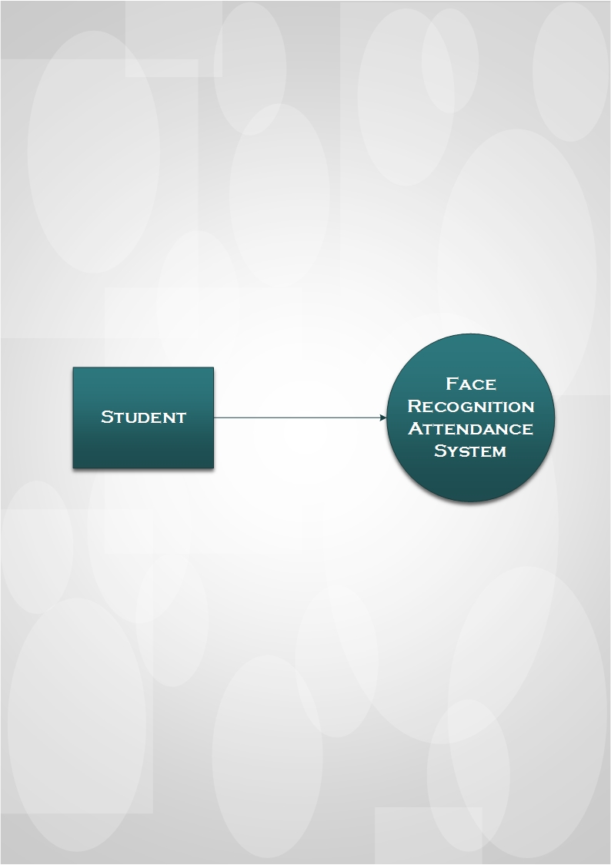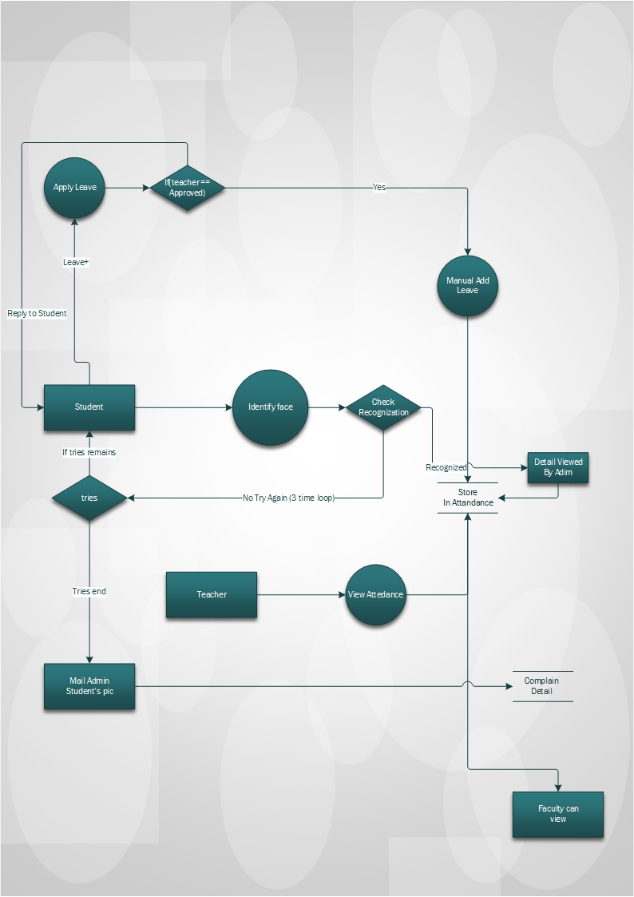

**Description:** This 0 level diagram show the basic relationship of a student to the face recognition system and the level 1 diagram shows the working of how the student and face recognition system interact and how the working of the system is occurring this diagram helps you to understand easily the working of our application.

1. **Use case diagram**

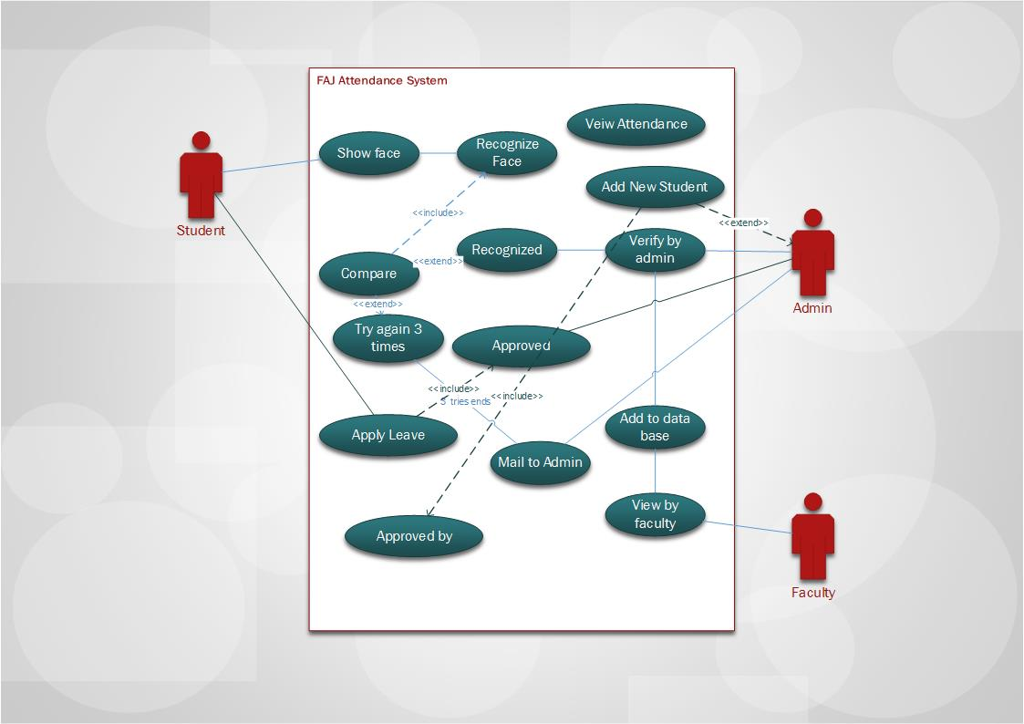

**Use case diagram**

**Description:** This use case diagram show the interaction of admin, student and faculty and how much part of the application they can access and how many part they play in the whole process of the application.

1. **Activity diagram (Swim lane)**

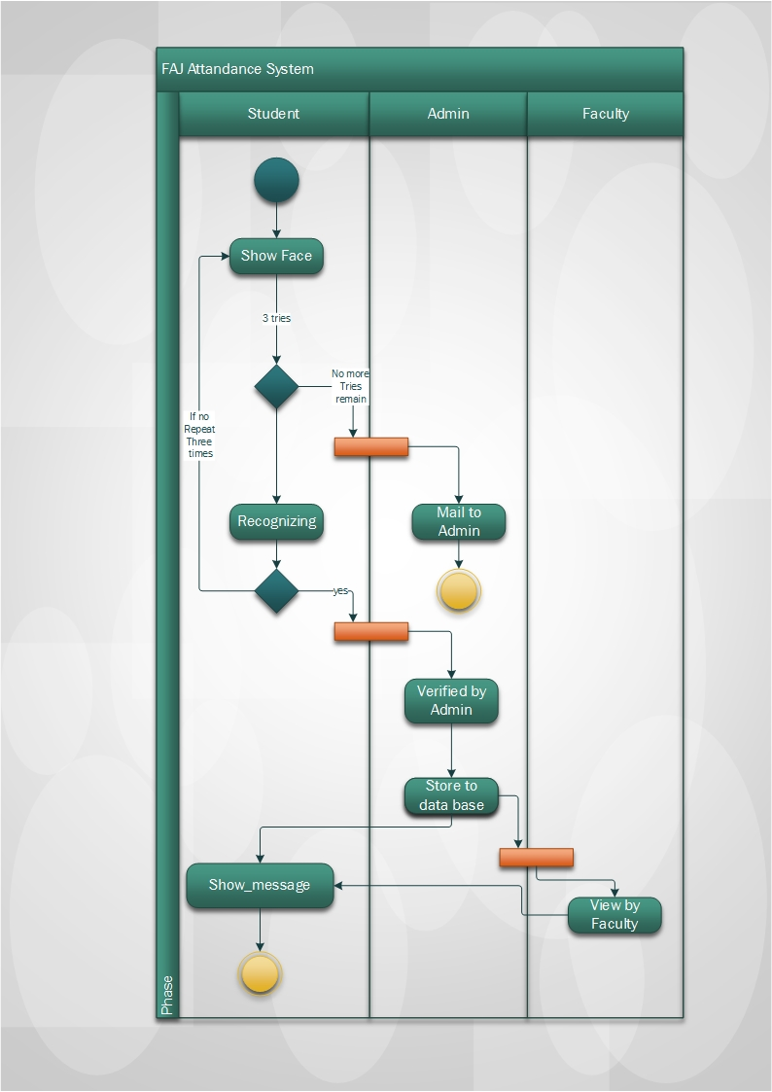

Activity diagram (Swim lane)

**Description:** This activity (swim lane) diagram show how the system is connected from one person to another and how it is connecting different people and their working is easily defined in this diagram about our application.

1. **State Machine Diagram**

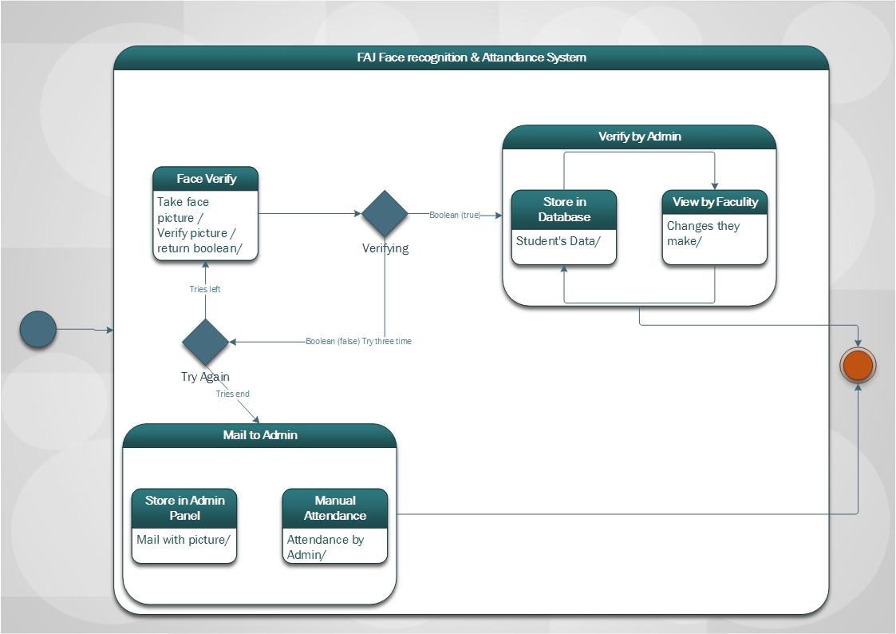State Machine Diagram

**Description:** State Machine diagram shows the different state of the application in which the different process are performing and that makes this diagram helpful in understanding the working on different parts and different steps.

1. **Sequence diagram**

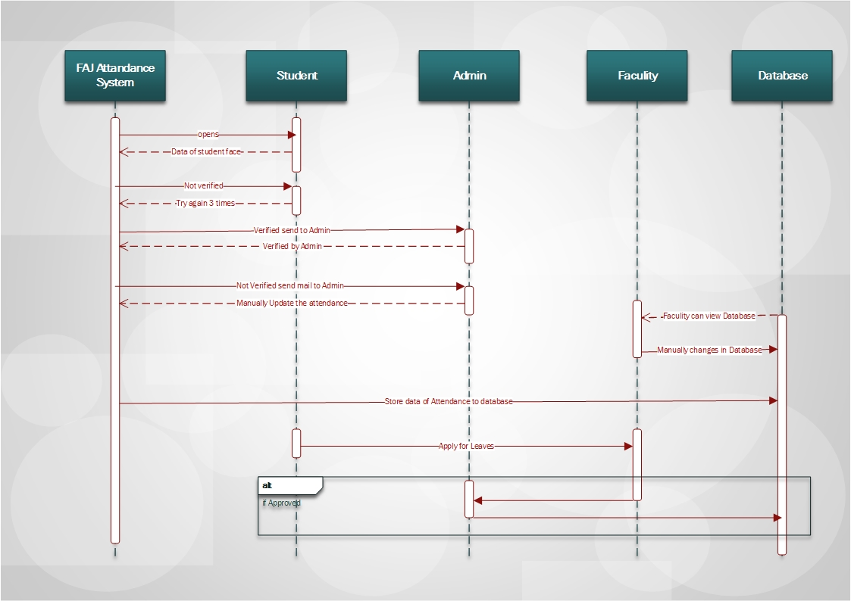

Sequence diagram

**Description:** This sequence diagram shows the process working in sequence and messages and objects creating from one to another and the working by different parts and how the sequence of the working is made.

1. **Class diagram**

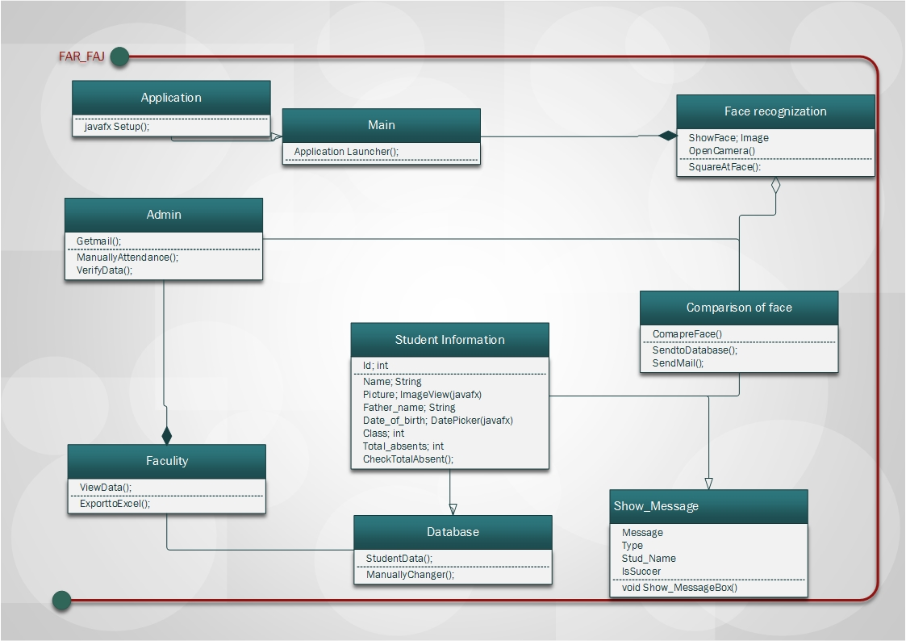

Class diagram

**Description:** This class diagram shows the working of the different classes that are created to do every single process as you can see that there are many classes that are connected associatively, aggregately and by inheritance.

1. **Object diagram**

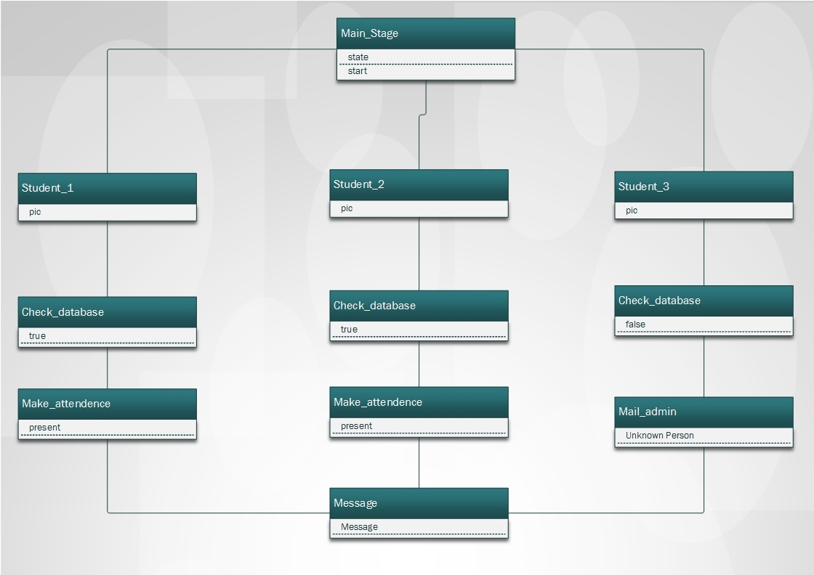

Object diagram

**Description:** The object diagram shows the different object that are created in the class and then their working shows what they done in a simple way that how it all done work the summaries form of objective has been shown in the object diagram

1. **Component Diagram**

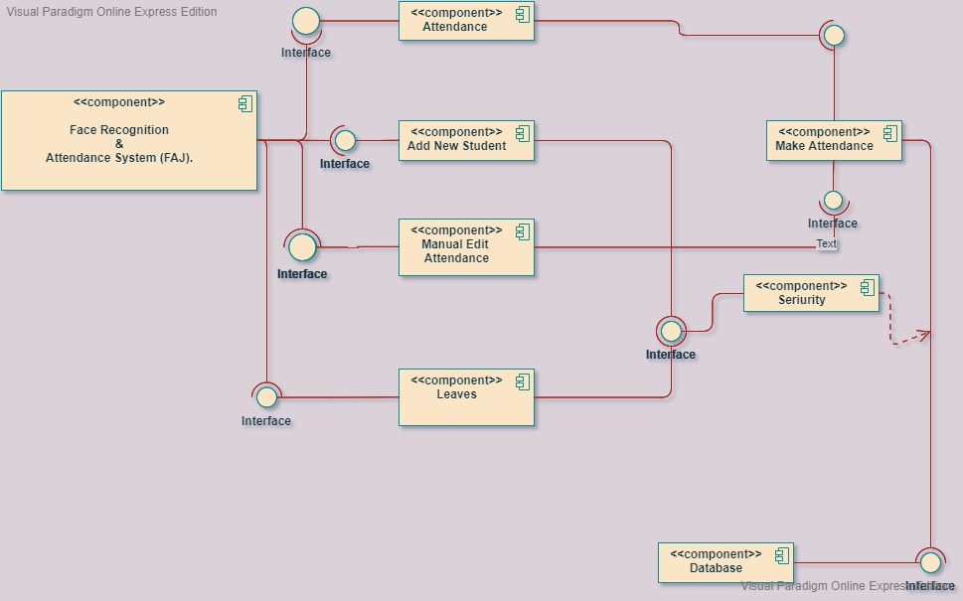

Component Diagram

**Description:** The component diagram shows the different component of the interface of different objects and what the working the components are making at different point.

1. **Entity Relationship Diagram (ERD)**

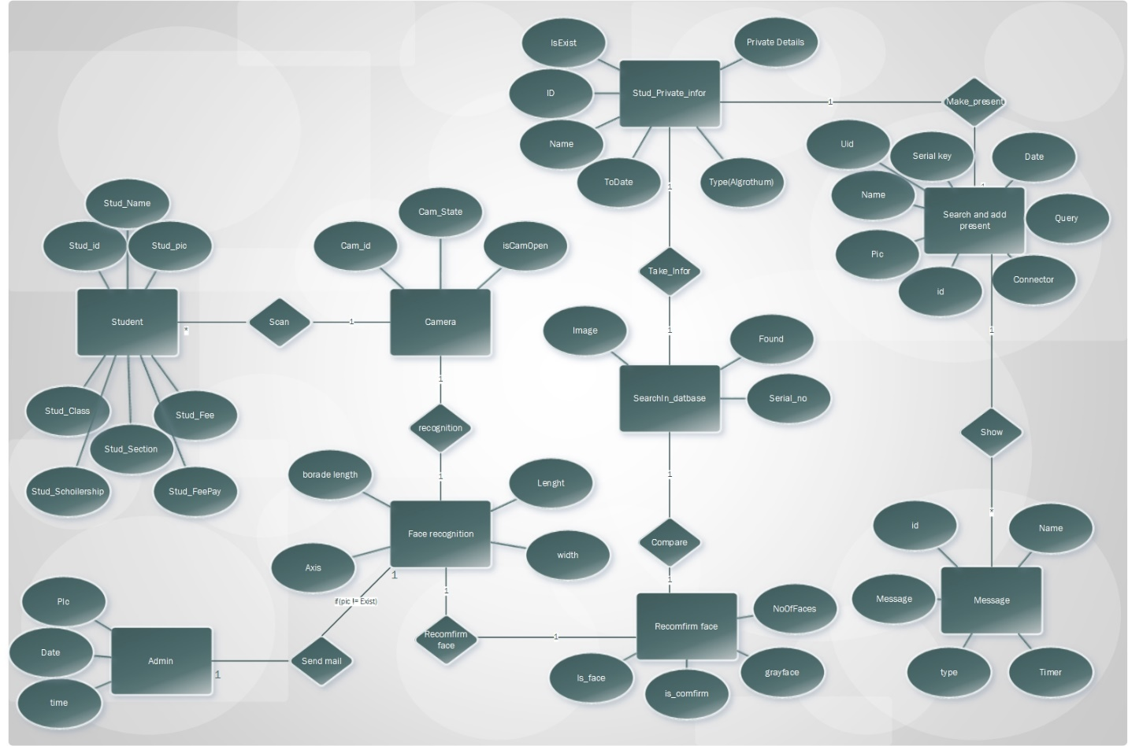

Entity Relationship Diagram (ERD)

**Description:** An entity diagram is used to show the detail version of the working and the relationship between one entity to other it not only show the relationship but describe the whole process in a detail method with every process that is happening in the diagram.